39.7: 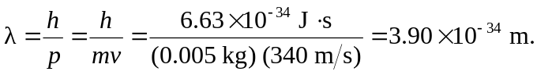
We should not expect the bullet to exhibit wavelike properties.

